

Psychology Board of Australia

Registrant data

Reporting period: 1 January 2018 – 31 March 2018

Table of contents
Introduction 3
Principal Place of Practice 4
1. Registration type 4
Endorsements 5
2. Endorsement by PPP 5
3. Number of endorsements 5
Supervisors 7
4. Board-approved supervisors 7
5. Registrar program supervisors 8
6. Approved supervisors of provisional psychologists 9
Age Group 10
7. Registration type by age group 10
Gender 12
8. Registration type 12
9. Percentage 12

Introduction
The role of the Psychology Board of Australia (the Board) includes:
- registering psychologists and provisional psychologists
- developing standards, codes and guidelines for the psychology profession
- handling notifications, complaints, investigations and disciplinary hearings
- overseeing the assessment of overseas trained psychologists who wish to practise in Australia, and
- approving accreditation standards and accredited courses of study.
The Board’s functions are supported by the Australian Health Practitioner Regulation Agency (AHPRA). For information about legislation governing our operations see About AHPRA at www.ahpra.gov.au/About-AHPRA/What-We-Do/Legislation.aspx.
The Board has analysed its registration data and produced a number of statistical breakdowns about registrants to share with the profession and community. The Board shares these breakdowns regularly.
For more information on psychology registration, please see the Board’s website www.psychologyboard.gov.au/Registration.aspx

Principal Place of Practice
Principal Place of Practice (PPP) is the address declared by the psychologist to be the address at which he or she is predominantly practising the profession. If the psychologist is not practising the profession or is not practising predominantly at one address the Principal Place of Practice may be the psychologist’s principal place of residence.
The ‘No PPP’ column in the tables on the following pages represents psychologists who do not have an Australian Principal Place of Practice recorded on the register usually because they are currently residing overseas or who have not provided a valid PPP.

- Registration Type
  - Registration type by principal place of practice
Registration Type | ACT | NSW | NT | QLD | SA | TAS | VIC | WA | No PPP | Total
General | 804 | 9,654 | 199 | 5,191 | 1,469 | 495 | 8,057 | 2,994 | 350 | 29,213
Provisional | 117 | 1,532 | 29 | 995 | 211 | 87 | 1,410 | 625 | 11 | 5,017
Non-practising | 36 | 569 | 3 | 272 | 84 | 30 | 343 | 142 | 197 | 1,676
Total | 957 | 11,755 | 231 | 6,458 | 1,764 | 612 | 9,810 | 3,761 | 558 | 35,906

  - Registration by principal place of practice percentages

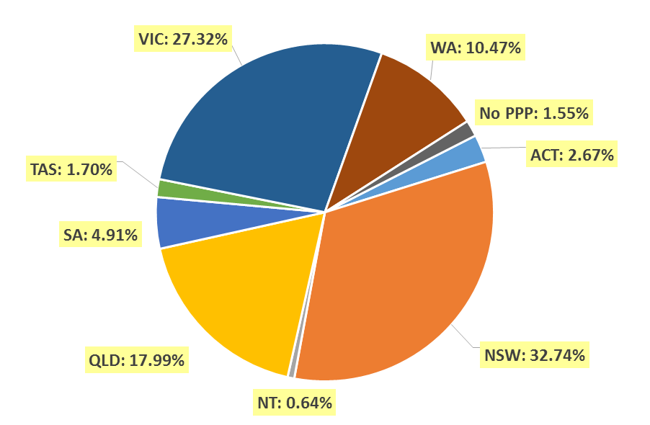
Endorsements
- Area of practice endorsements by PPP
  - Area of practice endorsements by state or territory
Area of practice | ACT | NSW | NT | QLD | SA | TAS | VIC | WA | No PPP | Total
Clinical neuropsychology | 9 | 162 | 2 | 105 | 25 | 6 | 298 | 33 | 11 | 651
Clinical psychology | 242 | 2,565 | 36 | 1,349 | 626 | 191 | 2,105 | 1,107 | 77 | 8,298
Community psychology | 1 | 6 |  | 3 | 1 |  | 34 | 10 |  | 55
Counselling psychology | 10 | 202 | 1 | 75 | 11 | 7 | 483 | 145 | 12 | 946
Educational and developmental psychology | 9 | 159 | 2 | 118 | 35 | 20 | 236 | 68 | 9 | 656
Forensic psychology | 14 | 221 | 6 | 69 | 38 | 9 | 164 | 47 | 4 | 572
Health psychology | 5 | 66 | 1 | 57 | 29 | 9 | 146 | 6 | 3 | 322
Organisational psychology | 16 | 168 | 2 | 76 | 49 | 2 | 153 | 41 | 6 | 513
Sport and exercise psychology | 5 | 23 | 1 | 25 | 7 | 3 | 22 | 6 |  | 92
Total | 311 | 3,572 | 51 | 1,877 | 821 | 247 | 3,641 | 1,463 | 122 | 12,105
* Note: The figures in the table above show the total number of psychology area of practice endorsements recorded on the National Register. Psychologists who hold more than one endorsement are counted for each endorsement they hold. The number of individual psychologists who hold at least one area of practice endorsement after the close of business on 31 March 2018 was 10,125.

- Number of Endorsements
  - Number of endorsements held
Endorsement | 1 | 2 | 3 | 4 | 6 | Total
Number of endorsed psychologists | 10,125 | 885 | 56 | 9 | 1 | 11,076
% of endorsed psychologists | 91.4% | 8.0% | .5% | 0.1% | <0.1% | 100.0%
Number of psychologists with general registration (endorsed and non-endorsed) |  |  |  |  |  | 29,213
% of all general psychologists with one or more endorsement | 34.7% | 3.0% | 0.2% | <0.1% | <0.1% | 37.9%

  - Psychologists with one endorsement per registrant and total number of endorsements – by area of practice
Area of practice | Psychologists with one endorsement | % of psychologists with one endorsement | Total endorsements | % of total endorsements
Clinical neuropsychology | 497 | 4.9% | 651 | 5.4%
Clinical psychology | 7,487 | 73.9% | 8,298 | 68.6%
Community psychology | 29 | 0.3% | 55 | 0.5%
Counselling psychology | 638 | 6.3% | 946 | 7.8%
Educational and developmental psychology | 477 | 4.7% | 656 | 5.4%
Forensic psychology | 319 | 3.2% | 572 | 4.7%
Health psychology | 162 | 1.6% | 322 | 2.7%
Organisational psychology | 443 | 4.4% | 513 | 4.2%
Sport and exercise psychology | 73 | 0.7% | 92 | 0.8%
Total | 10,125 | 100.0% | 12,105 | 100.0%

* Note: The sum of individual proportions may not add up to 100% due to rounding

Supervisors
- Board-approved supervisors
  - Approved supervisors by PPP
PPP | Number of approved supervisors | % of general registrants1
ACT | 288 | 35.8%
NSW | 3,420 | 35.4%
NT | 59 | 29.6%
QLD | 1,741 | 33.5%
SA | 522 | 35.5%
TAS | 208 | 42.0%
VIC | 2,271 | 28.2%
WA | 1,166 | 38.9%
No PPP | 54 | 15.4%
Total | 9,729 | 33.3%

  - Change in the number of approved supervisors⁴
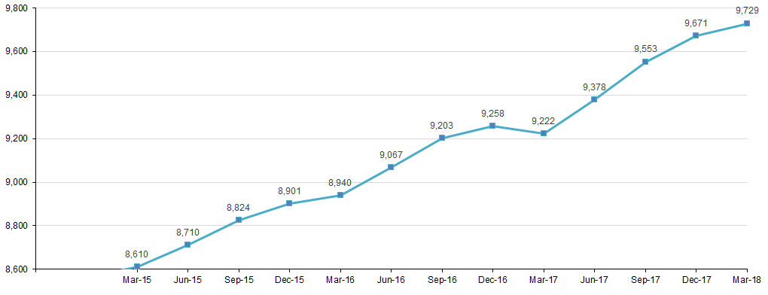
- Registrar program supervisors
  - Registrar program supervisors
PPP | Supervisor Type | Clinical neuropsychology | Clinical psychology | Community psychology | Counselling psychology | Educational and developmental psychology | Forensic psychology | Health psychology | Organisational psychology | Sport and exercise psychology | Any area of practice | Total
ACT | Principal | 5 | 106 |  | 3 | 2 | 8 | 2 | 5 | 1 |  | 132
ACT | Secondary | 6 | 76 |  | 2 |  | 4 | 1 | 4 | 1 | 79 | 173
NSW | Principal | 88 | 1,028 | 2 | 50 | 53 | 108 | 20 | 62 | 9 |  | 1,420
NSW | Secondary | 78 | 835 | 2 | 38 | 38 | 92 | 13 | 56 | 5 | 369 | 1,526
NT | Principal | 1 | 13 |  |  |  | 3 |  | 1 |  |  | 18
NT | Secondary | 1 | 12 |  |  | 1 |  | 1 | 1 |  | 7 | 23
QLD | Principal | 53 | 547 | 1 | 34 | 50 | 36 | 31 | 36 | 10 |  | 798
QLD | Secondary | 13 | 166 | 1 | 10 | 14 | 8 | 13 | 15 | 3 | 656 | 899
SA | Principal | 15 | 260 |  | 5 | 19 | 20 | 17 | 15 | 3 |  | 354
SA | Secondary | 5 | 93 |  | 3 | 3 | 6 | 5 | 6 |  | 238 | 359
TAS | Principal | 3 | 92 |  | 3 | 10 | 6 | 4 | 1 | 1 |  | 120
TAS | Secondary | 2 | 74 |  | 1 | 10 | 5 | 2 | 1 |  | 37 | 132
VIC | Principal | 172 | 823 | 20 | 188 | 85 | 72 | 53 | 56 | 7 |  | 1,476
VIC | Secondary | 103 | 534 | 13 | 111 | 51 | 57 | 38 | 39 | 6 | 561 | 1,513
WA | Principal | 18 | 516 | 2 | 64 | 24 | 23 |  | 12 | 2 |  | 661
WA | Secondary | 7 | 286 | 2 | 34 | 10 | 6 |  | 10 | 3 | 308 | 666
No PPP | Principal | 2 | 12 |  | 3 | 1 | 2 | 1 |  |  |  | 21
No PPP | Secondary | 1 | 9 |  | 1 | 1 | 2 |  |  |  | 13 | 27
Total |  | 573 | 5,481 | 43 | 550 | 372 | 458 | 201 | 320 | 51 | 2,269 | 10,318

- Board-approved supervisors of provisional psychologists
  - Approved supervisors by PPP
PPP | 4+2 internship |  | 5+1 program |  | Higher Degree program3 | Work in Addition to Higher Degree4
PPP | Principal | Secondary | Principal | Secondary | Higher Degree program3 | Work in Addition to Higher Degree4
ACT | 242 | 247 | 135 | 142 | 133 | 135
NSW | 2,849 | 2,789 | 1,476 | 1,519 | 1,582 | 1,089
NT | 50 | 55 | 14 | 17 | 23 | 18
QLD | 1,508 | 1,568 | 837 | 868 | 1,012 | 832
SA | 387 | 390 | 155 | 162 | 342 | 268
TAS | 170 | 175 | 109 | 115 | 116 | 111
VIC | 1,603 | 1,629 | 805 | 837 | 1,691 | 1,185
WA | 933 | 933 | 486 | 478 | 567 | 453
No PPP | 41 | 38 | 20 | 20 | 32 | 25
Total | 7,783 | 7,824 | 4,037 | 4,158 | 5,498 | 4,116
*Note: The figures in the table above include instances of the same supervisors counted more than once because they are approved to supervise in more than one provisional registration pathway area and/or for both principal and secondary where applicable.

Age group
- Registration type by age group
  - Registration type by age group
Age Group | General | Provisional | Non-practising | Total
U - 25 | 82 | 955 | 1 | 1,038
25 - 29 | 2,161 | 1,751 | 65 | 3,977
30 - 34 | 4,031 | 834 | 296 | 5,161
35 - 39 | 4,302 | 499 | 258 | 5,059
40 - 44 | 4,147 | 365 | 176 | 4,688
45 - 49 | 3,614 | 293 | 151 | 4,058
50 - 54 | 2,857 | 180 | 103 | 3,140
55 - 59 | 2,827 | 102 | 125 | 3,054
60 - 64 | 2,310 | 23 | 154 | 2,487
65 - 69 | 1,740 | 10 | 192 | 1,942
70 - 74 | 850 | 4 | 105 | 959
75 - 79 | 222 | 1 | 39 | 262
80+ | 70 |  | 11 | 81
Total | 29,213 | 5,017 | 1,676 | 35,906

  - Registrants by age group
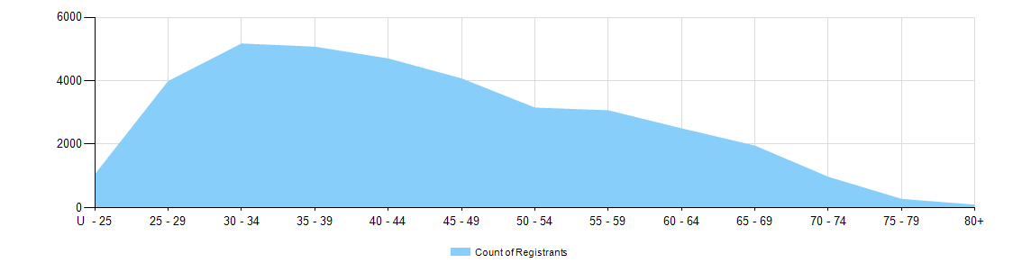
Gender
- Registration type
  - Psychology registrants by gender, by state and territory and by registration type
Gender | Registration type |  | ACT | NSW | NT | QLD | SA | TAS | VIC | WA | No PPP | Total
Female | General |  | 659 | 7,633 | 155 | 4,147 | 1,117 | 400 | 6,460 | 2,382 | 260 | 23,213
Female | Provisional |  | 99 | 1,239 | 22 | 801 | 167 | 76 | 1,148 | 531 | 11 | 4,094
Female | Non-practising |  | 25 | 455 | 2 | 220 | 67 | 24 | 290 | 123 | 154 | 1,360
Total female |  |  | 783 | 9,327 | 179 | 5,168 | 1,351 | 500 | 7,898 | 3,036 | 425 | 28,667
Male | General |  | 145 | 2,019 | 44 | 1,044 | 352 | 95 | 1,597 | 612 | 90 | 5,998
Male | Provisional |  | 18 | 293 | 7 | 194 | 44 | 11 | 262 | 93 |  | 922
Male | Non-practising |  | 11 | 114 | 1 | 52 | 17 | 6 | 53 | 19 | 43 | 316
Total male |  |  | 174 | 2,426 | 52 | 1,290 | 413 | 112 | 1,912 | 724 | 133 | 7,236
Intersex or Indeterminate |  | General |  | 2 |  |  |  |  |  |  |  | 2
 |  | Provisional |  |  |  |  |  |  |  | 1 |  | 1
Total Intersex or Indeterminate |  |  |  | 2 |  |  |  |  |  | 1 |  | 3
Total |  |  | 957 | 11,755 | 231 | 6,458 | 1,764 | 612 | 9,810 | 3,761 | 558 | 35,906

- Percentage
  - Registrants by gender percentages
Gender | ACT | NSW | NT | QLD | SA | TAS | VIC | WA | No PPP | Total
Female | 81.8% | 79.3% | 77.5% | 80.0% | 76.6% | 81.7% | 80.5% | 80.7% | 76.2% | 79.8%
Male | 18.2% | 20.6% | 22.5% | 20.0% | 23.4% | 18.3% | 19.5% | 19.3% | 23.8% | 20.2%
Intersex or Indeterminate |  | <0.1% |  |  |  |  |  | <0.1% |  | <0.1%

1 There were 29,213 psychologists with general registration after the close of business on 31 March 2018.
Provisional psychologists hold provisional registration which is the registration type under section 62 of the National Law that enables the individual to undertake a period of supervised practice in order to become eligible for general registration. There are different pathways that can be undertaken by registered provisional psychologists including the 4+2 internship program, the 5+1 internship program, and higher degree programs. Refer to the Provisional registration section of the Board’s website www.psychologyboard.gov.au for more information on the pathways.
3 Since 1 July 2013 all supervisors of psychology higher degree students undertaking placements must be approved by the Board.
4 Refer to the Board’s Policy on working in addition to placements.

