

Psychology Board of Australia

Registrant data

Reporting period: 1 July 2018 – 30 September 2018

Table of contents
Introduction 3
Principal Place of Practice 4
1. Registration type 4
Endorsements 5
2. Endorsement by PPP 5
3. Number of endorsements 5
Supervisors 7
4. Board-approved supervisors 7
5. Registrar program supervisors 8
Age Group 9
7. Registration type by age group 9
Gender 10
8. Registration type 10
9. Percentage 10

Introduction
The role of the Psychology Board of Australia (the Board) includes:
- registering psychologists and provisional psychologists
- developing standards, codes and guidelines for the psychology profession
- handling notifications, complaints, investigations and disciplinary hearings
- overseeing the assessment of overseas trained psychologists who wish to practise in Australia, and
- approving accreditation standards and accredited courses of study.
The Board’s functions are supported by the Australian Health Practitioner Regulation Agency (AHPRA). For information about legislation governing our operations see About AHPRA at www.ahpra.gov.au/About-AHPRA/What-We-Do/Legislation.aspx.
The Board has analysed its registration data and produced a number of statistical breakdowns about registrants to share with the profession and community. The Board shares these breakdowns regularly.
For more information on psychology registration, please see the Board’s website www.psychologyboard.gov.au/Registration.aspx

Principal Place of Practice
Principal Place of Practice (PPP) is the address declared by the psychologist to be the address at which he or she is predominantly practising the profession. If the psychologist is not practising the profession or is not practising predominantly at one address the Principal Place of Practice may be the psychologist’s principal place of residence.
The ‘No PPP’ column in the tables on the following pages represents psychologists who do not have an Australian Principal Place of Practice recorded on the register usually because they are currently residing overseas or who have not provided a valid PPP.

- Registration Type
  - Registration type by principal place of practice
Registration Type | ACT | NSW | NT | QLD | SA | TAS | VIC | WA | No PPP | Total
General | 813 | 9,836 | 207 | 5,308 | 1,496 | 512 | 8,266 | 3,039 | 366 | 29,843
Provisional | 115 | 1,606 | 25 | 983 | 207 | 89 | 1,409 | 626 | 15 | 5,075
Non-practising | 37 | 562 | 2 | 285 | 81 | 29 | 334 | 141 | 203 | 1,674
Total | 965 | 12,004 | 234 | 6,576 | 1,784 | 630 | 10,009 | 3,806 | 584 | 36,592

  - Registration by principal place of practice percentages

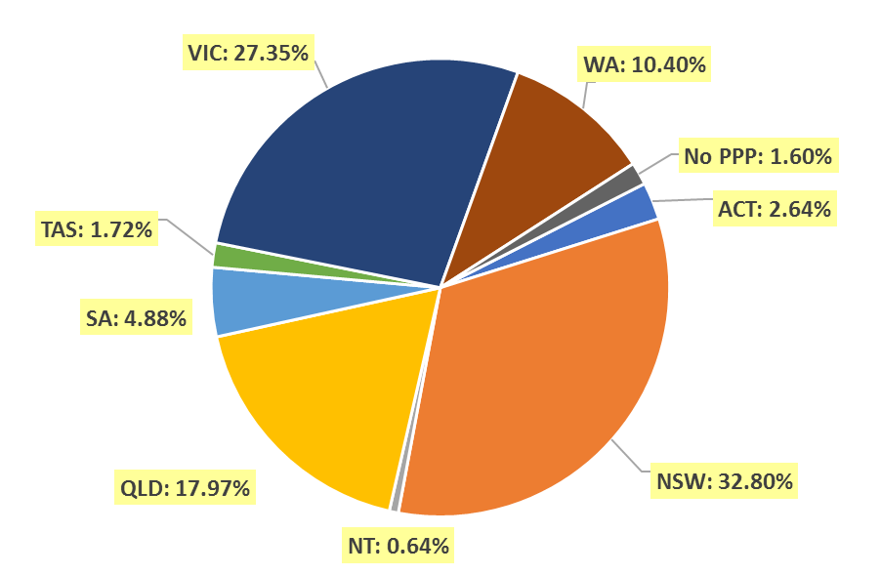
Endorsements
- Area of practice endorsements by PPP
  - Area of practice endorsements by state or territory
Area of practice | ACT | NSW | NT | QLD | SA | TAS | VIC | WA | No PPP | Total
Clinical neuropsychology | 10 | 165 | 2 | 106 | 26 | 6 | 310 | 35 | 11 | 671
Clinical psychology | 255 | 2,651 | 38 | 1,411 | 653 | 202 | 2,204 | 1,150 | 89 | 8,653
Community psychology | 1 | 6 |  | 3 | 1 |  | 34 | 10 |  | 55
Counselling psychology | 10 | 204 | 1 | 76 | 11 | 7 | 494 | 150 | 10 | 963
Educational and developmental psychology | 10 | 159 | 2 | 120 | 35 | 20 | 250 | 66 | 8 | 670
Forensic psychology | 14 | 230 | 6 | 70 | 37 | 9 | 172 | 49 | 4 | 591
Health psychology | 5 | 67 | 1 | 59 | 29 | 9 | 146 | 5 | 3 | 324
Organisational psychology | 18 | 177 | 2 | 80 | 49 | 2 | 155 | 41 | 6 | 530
Sport and exercise psychology | 5 | 21 | 1 | 27 | 7 | 3 | 23 | 6 |  | 93
Total | 328 | 3,680 | 53 | 1,952 | 848 | 258 | 3,788 | 1,512 | 131 | 12,550
The figures in the table above show the total number of psychology area of practice endorsements recorded on the National Register. Psychologists who hold more than one endorsement are counted for each endorsement they hold. The number of individual psychologists who hold at least one area of practice endorsement after the close of business on 30 September 2018 was 11,510.

- Number of Endorsements
  - Number of endorsements held
Endorsement | 1 | 2 | 3 | 4 | 5 | 6 | Total
Number of endorsed psychologists | 10,549 | 895 | 56 | 8 | 1 | 1 | 11,510
% of endorsed psychologists | 91.7% | 7.8% | 0.5% | 0.1% | <0.1% | <0.1% | 100.0%
Number of psychologists with general registration (endorsed and non-endorsed) |  |  |  |  |  |  | 29,843
% of all general psychologists with one or more endorsement | 35.3% | 3.0% | 0.2% | <0.1% | <0.1% | <0.1% | 38.6%

  - Psychologists with one endorsement per registrant and total number of endorsements – by area of practice
Area of practice | Psychologists with one endorsement | % of psychologists with one endorsement | Total endorsements | % of total endorsements
Clinical neuropsychology | 513 | 4.9% | 671 | 5.3%
Clinical psychology | 7,832 | 74.2% | 8,653 | 68.9%
Community psychology | 29 | 0.3% | 55 | 0.4%
Counselling psychology | 653 | 6.2% | 963 | 7.7%
Educational and developmental psychology | 489 | 4.6% | 670 | 5.3%
Forensic psychology | 334 | 3.2% | 591 | 4.7%
Health psychology | 165 | 1.6% | 324 | 2.6%
Organisational psychology | 460 | 4.4% | 530 | 4.2%
Sport and exercise psychology | 74 | 0.7% | 93 | 0.7%
Total | 10,549 | 100.0% | 12,550 | 100.0%
The sum of individual proportions may not add up to 100% due to rounding.
Supervisors
- Board-approved supervisors
  - Approved supervisors by PPP
PPP | Number of approved supervisors | % of general registrants
ACT | 246 | 25.5%
NSW | 2,570 | 21.4%
NT | 52 | 22.2%
QLD | 1,409 | 21.4%
SA | 409 | 22.9%
TAS | 172 | 27.3%
VIC | 1,860 | 18.6%
WA | 887 | 23.3%
No PPP | 32 | 5.5%
Total | 7,637 | 20.9%

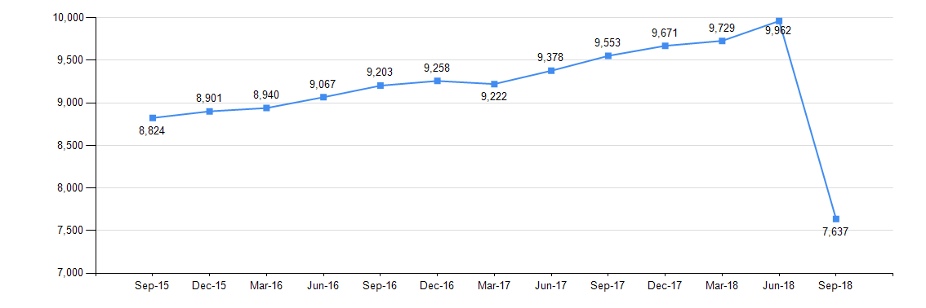
  - Change in the number of approved supervisors

8,500 psychologists were approved, under transitional arrangements in 2013, to provide supervision until 30 June 2018. 2,900 did not renew their supervision approvals, accounting for the decline in total approved supervisors in September 2018.
- Registrar program supervisors
  - Registrar program principal supervisors
Area of practice | ACT | NSW | NT | QLD | SA | TAS | VIC | WA | No PPP | Total
Clinical neuropsychology | 5 | 82 | 2 | 56 | 14 | 4 | 185 | 21 | 2 | 371
Clinical psychology | 119 | 1,038 | 20 | 589 | 247 | 84 | 887 | 480 | 9 | 3,473
Community psychology | 1 | 1 | 1 | 1 | 1 | 1 | 17 | 2 | 1 | 26
Counselling psychology | 3 | 45 | 1 | 35 | 5 | 1 | 173 | 64 | 1 | 328
Educational and developmental psychology | 2 | 56 | 1 | 57 | 17 | 6 | 84 | 21 | 1 | 245
Forensic psychology | 10 | 116 | 2 | 35 | 20 | 5 | 80 | 23 | 2 | 293
Health psychology | 4 | 24 | 1 | 30 | 14 | 3 | 58 | 1 | 1 | 136
Organisational psychology | 6 | 58 | 1 | 40 | 17 | 2 | 57 | 13 | 1 | 195
Sport and exercise psychology | 1 | 3 | 1 | 8 | 2 | 1 | 4 | 2 | 1 | 23
Total | 151 | 1,3 | 30 | 851 | 337 | 107 | 1,545 | 627 | 19 | 5,090
On 1 August 2018, the Board introduced new Guidelines for supervisors which removed all supervisor approval categories except 'Registrar program principal supervisor'.
Age group
- Registration type by age group
  - Registration type by age group
Age Group | General | Provisional | Non-practising | Total
U - 25 | 61 | 908 | 2 | 971
25 - 29 | 2,109 | 1,789 | 46 | 3,944
30 - 34 | 4,060 | 856 | 274 | 5,190
35 - 39 | 4,478 | 506 | 259 | 5,243
40 - 44 | 4,168 | 371 | 181 | 4,720
45 - 49 | 3,786 | 300 | 153 | 4,239
50 - 54 | 2,886 | 189 | 104 | 3,179
55 - 59 | 2,861 | 108 | 131 | 3,100
60 - 64 | 2,378 | 35 | 150 | 2,563
65 - 69 | 1,776 | 8 | 194 | 1,978
70 - 74 | 934 | 3 | 121 | 1,058
75 - 79 | 267 | 2 | 46 | 315
80+ | 79 |  | 13 | 92
Total | 29,843 | 5,075 | 1,674 | 36,592

  - Registrants by age group
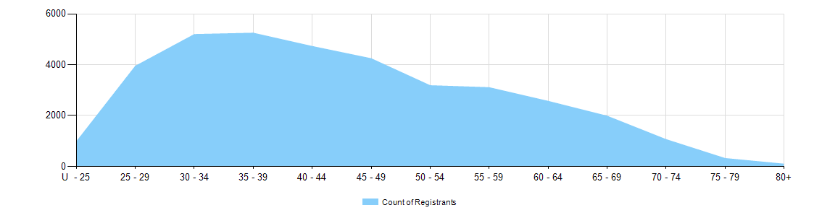
Gender
- Registration type
  - Psychology registrants by gender, by state and territory and by registration type
Gender | Registration type |  | ACT | NSW | NT | QLD | SA | TAS | VIC | WA | No PPP | Total
Female | General |  | 666 | 7,799 | 161 | 4,238 | 1,138 | 414 | 6,633 | 2,421 | 273 | 23,743
Female | Provisional |  | 98 | 1,298 | 21 | 782 | 164 | 76 | 1,161 | 531 | 13 | 4,144
Female | Non-practising |  | 25 | 440 | 1 | 231 | 64 | 22 | 278 | 121 | 158 | 1,340
Total female |  |  | 789 | 9,537 | 183 | 5,251 | 1,366 | 512 | 8,072 | 3,073 | 444 | 29,227
Male | General |  | 147 | 2,035 | 46 | 1,070 | 358 | 98 | 1,633 | 618 | 93 | 6,098
Male | Provisional |  | 17 | 308 | 4 | 201 | 43 | 13 | 248 | 94 | 2 | 930
Male | Non-practising |  | 12 | 122 | 1 | 54 | 17 | 7 | 56 | 20 | 45 | 334
Total male |  |  | 176 | 2,465 | 51 | 1,325 | 418 | 118 | 1,937 | 732 | 140 | 7,362
Intersex or Indeterminate |  | General |  | 2 |  |  |  |  |  |  |  | 2
 |  | Provisional |  |  |  |  |  |  |  | 1 |  | 1
Total Intersex or Indeterminate |  |  |  | 2 |  |  |  |  |  | 1 |  | 3
Total |  |  | 965 | 12,004 | 234 | 6,576 | 1,784 | 630 | 10,009 | 3,806 | 584 | 36,592

- Percentage
  - Registrants by gender percentages
Gender | ACT | NSW | NT | QLD | SA | TAS | VIC | WA | No PPP | Total
Female | 81.8% | 79.4% | 78.2% | 79.9% | 76.6% | 81.3% | 80.6% | 80.7% | 76.0% | 79.9%
Male | 18.2% | 20.5% | 21.8% | 20.1% | 23.4% | 18.7% | 19.4% | 19.2% | 24.0% | 20.1%
Intersex or Indeterminate |  | <0.1% |  |  |  |  |  | <0.1% |  | <0.1%

