

Psychology Board of Australia

Registrant data

Reporting period: 1 April 2018 – 30 June 2018

Table of contents
Introduction 3
Principal Place of Practice 4
1. Registration type 4
Endorsements 5
2. Endorsement by PPP 5
3. Number of endorsements 5
Supervisors 7
4. Board-approved supervisors 7
5. Registrar program supervisors 8
6. Approved supervisors of provisional psychologists 9
Age Group 10
7. Registration type by age group 10
Gender 12
8. Registration type 12
9. Percentage 12

Introduction
The role of the Psychology Board of Australia (the Board) includes:
- registering psychologists and provisional psychologists
- developing standards, codes and guidelines for the psychology profession
- handling notifications, complaints, investigations and disciplinary hearings
- overseeing the assessment of overseas trained psychologists who wish to practise in Australia, and
- approving accreditation standards and accredited courses of study.
The Board’s functions are supported by the Australian Health Practitioner Regulation Agency (AHPRA). For information about legislation governing our operations see About AHPRA at www.ahpra.gov.au/About-AHPRA/What-We-Do/Legislation.aspx.
The Board has analysed its registration data and produced a number of statistical breakdowns about registrants to share with the profession and community. The Board shares these breakdowns regularly.
For more information on psychology registration, please see the Board’s website www.psychologyboard.gov.au/Registration.aspx

Principal Place of Practice
Principal Place of Practice (PPP) is the address declared by the psychologist to be the address at which he or she is predominantly practising the profession. If the psychologist is not practising the profession or is not practising predominantly at one address the Principal Place of Practice may be the psychologist’s principal place of residence.
The ‘No PPP’ column in the tables on the following pages represents psychologists who do not have an Australian Principal Place of Practice recorded on the register usually because they are currently residing overseas or who have not provided a valid PPP.

- Registration Type
  - Registration type by principal place of practice
Registration Type | ACT | NSW | NT | QLD | SA | TAS | VIC | WA | No PPP | Total
General | 810 | 9,768 | 201 | 5,262 | 1,482 | 505 | 8,191 | 3,026 | 353 | 29,598
Provisional | 114 | 1,623 | 28 | 970 | 205 | 94 | 1,441 | 631 | 10 | 5,116
Non-practising | 37 | 565 | 2 | 271 | 85 | 29 | 334 | 137 | 202 | 1,662
Total | 961 | 11,956 | 231 | 6,503 | 1,772 | 628 | 9,966 | 3,794 | 565 | 36,376

  - Registration by principal place of practice percentages

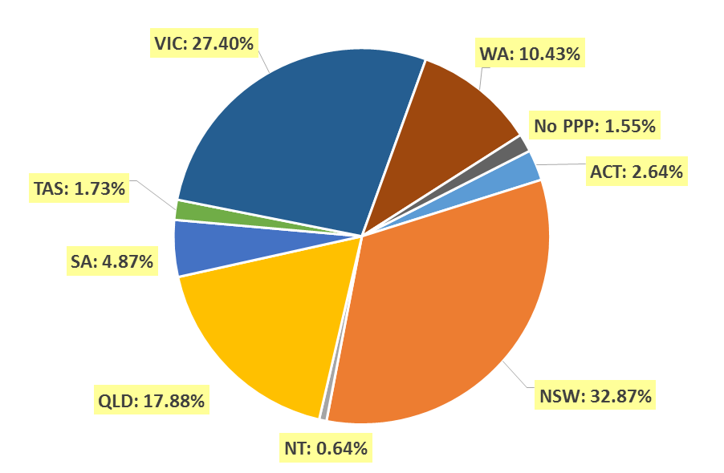
Endorsements
- Area of practice endorsements by PPP
  - Area of practice endorsements by state or territory
Area of practice | ACT | NSW | NT | QLD | SA | TAS | VIC | WA | No PPP | Total
Clinical neuropsychology | 10 | 163 | 2 | 105 | 25 | 6 | 304 | 35 | 11 | 661
Clinical psychology | 252 | 2,612 | 37 | 1,384 | 638 | 197 | 2,160 | 1,136 | 79 | 8,495
Community psychology | 1 | 6 |  | 3 | 1 |  | 34 | 10 |  | 55
Counselling psychology | 10 | 201 | 1 | 75 | 11 | 7 | 484 | 147 | 12 | 948
Educational and developmental psychology | 10 | 159 | 2 | 120 | 35 | 20 | 241 | 67 | 9 | 663
Forensic psychology | 14 | 227 | 6 | 69 | 37 | 9 | 169 | 46 | 4 | 581
Health psychology | 5 | 67 | 1 | 60 | 29 | 9 | 145 | 6 | 3 | 325
Organisational psychology | 17 | 171 | 2 | 79 | 48 | 2 | 154 | 41 | 5 | 519
Sport and exercise psychology | 5 | 23 | 1 | 25 | 7 | 3 | 22 | 6 |  | 92
Total | 324 | 3,629 | 52 | 1,920 | 831 | 253 | 3,713 | 1,494 | 123 | 12,339
* Note: The figures in the table above show the total number of psychology area of practice endorsements recorded on the National Register. Psychologists who hold more than one endorsement are counted for each endorsement they hold. The number of individual psychologists who hold at least one area of practice endorsement after the close of business on 30 June 2018 was 10,355.

- Number of Endorsements
  - Number of endorsements held
Endorsement | 1 | 2 | 3 | 4 | 6 | Total
Number of endorsed psychologists | 10,355 | 887 | 56 | 9 | 1 | 11,308
% of endorsed psychologists | 91.6% | 7.8% | 0.5% | 0.1% | <0.1% | 100.0%
Number of psychologists with general registration (endorsed and non-endorsed) |  |  |  |  |  | 29,598
% of all general psychologists with one or more endorsement | 35.0% | 3.0% | 0.2% | <0.1% | <0.1% | 38.2%

  - Psychologists with one endorsement per registrant and total number of endorsements – by area of practice
Area of practice | Psychologists with one endorsement | % of psychologists with one endorsement | Total endorsements | % of total endorsements
Clinical neuropsychology | 504 | 4.9% | 661 | 5.4%
Clinical psychology | 7,682 | 74.2% | 8,495 | 68.8%
Community psychology | 29 | 0.3% | 55 | 0.4%
Counselling psychology | 640 | 6.2% | 948 | 7.7%
Educational and developmental psychology | 484 | 4.7% | 663 | 5.4%
Forensic psychology | 329 | 3.2% | 581 | 4.7%
Health psychology | 165 | 1.6% | 325 | 2.6%
Organisational psychology | 449 | 4.3% | 519 | 4.2%
Sport and exercise psychology | 73 | 0.7% | 92 | 0.7%
Total | 10,355 | 100.0% | 12,339 | 100.0%

* Note: The sum of individual proportions may not add up to 100% due to rounding

Supervisors
- Board-approved supervisors
  - Approved supervisors by PPP
PPP | Number of approved supervisors | % of general registrants1
ACT | 292 | 36.0%
NSW | 3,463 | 35.5%
NT | 58 | 28.9%
QLD | 1,798 | 34.2%
SA | 532 | 35.9%
TAS | 212 | 42.0%
VIC | 2,366 | 28.9%
WA | 1,189 | 39.3%
No PPP | 52 | 14.7%
Total | 9,962 | 33.7%

  - Change in the number of approved supervisors
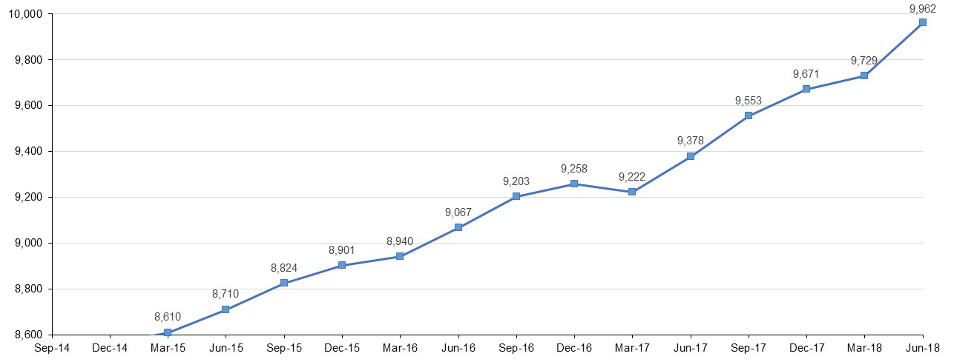
- Registrar program supervisors
  - Registrar program supervisors
PPP | Supervisor Type | Clinical neuropsychology | Clinical psychology | Community psychology | Counselling psychology | Educational and developmental psychology | Forensic psychology | Health psychology | Organisational psychology | Sport and exercise psychology | Any area of practice | Total
ACT | Principal | 5 | 112 |  | 3 | 3 | 9 | 4 | 6 | 1 |  | 143
ACT | Secondary | 6 | 80 |  | 2 | 1 | 4 | 2 | 4 | 1 | 77 | 177
NSW | Principal | 90 | 1,089 | 3 | 54 | 58 | 120 | 25 | 64 | 9 |  | 1,512
NSW | Secondary | 74 | 829 | 2 | 37 | 35 | 90 | 15 | 55 | 5 | 451 | 1,593
NT | Principal | 1 | 14 |  |  |  | 3 |  | 1 |  |  | 19
NT | Secondary | 1 | 11 |  |  | 1 |  | 1 |  |  | 9 | 23
QLD | Principal | 57 | 604 | 1 | 38 | 56 | 37 | 33 | 42 | 11 |  | 879
QLD | Secondary | 12 | 171 | 1 | 9 | 14 | 6 | 14 | 16 | 4 | 746 | 993
SA | Principal | 15 | 275 |  | 6 | 19 | 20 | 17 | 20 | 2 |  | 374
SA | Secondary | 6 | 102 |  | 3 | 1 | 9 | 5 | 6 |  | 235 | 367
TAS | Principal | 4 | 94 |  | 3 | 10 | 6 | 4 | 2 | 1 |  | 124
TAS | Secondary | 3 | 71 |  | 1 | 10 | 5 | 1 | 2 |  | 41 | 134
VIC | Principal | 190 | 891 | 20 | 200 | 92 | 78 | 60 | 67 | 8 |  | 1,606
VIC | Secondary | 125 | 606 | 14 | 121 | 59 | 63 | 45 | 49 | 7 | 609 | 1,698
WA | Principal | 20 | 544 | 3 | 70 | 25 | 27 |  | 12 | 2 |  | 703
WA | Secondary | 8 | 285 | 2 | 34 | 11 | 8 |  | 9 | 3 | 338 | 698
No PPP | Principal | 2 | 12 |  | 3 | 1 | 2 | 1 |  |  |  | 21
No PPP | Secondary | 1 | 8 |  | 1 | 1 | 2 |  |  |  | 14 | 27
Total |  | 620 | 5,798 | 46 | 585 | 397 | 489 | 227 | 355 | 54 | 2,520 | 11,091

- Board-approved supervisors of provisional psychologists
  - Approved supervisors by PPP
PPP | 4+2 internship |  | 5+1 program |  | Higher Degree program3 | Work in Addition to Higher Degree4
PPP | Principal | Secondary | Principal | Secondary | Higher Degree program3 | Work in Addition to Higher Degree4
ACT | 243 | 249 | 167 | 175 | 142 | 146
NSW | 2,836 | 2,814 | 1,862 | 1,922 | 1,632 | 1,180
NT | 48 | 53 | 25 | 28 | 26 | 20
QLD | 1,541 | 1,610 | 1,082 | 1,126 | 1,038 | 905
SA | 381 | 395 | 242 | 254 | 351 | 274
TAS | 166 | 170 | 131 | 138 | 120 | 121
VIC | 1,733 | 1,777 | 1,187 | 1,229 | 1,765 | 1,403
WA | 981 | 975 | 672 | 672 | 613 | 524
No PPP | 40 | 37 | 24 | 24 | 29 | 25
Total | 7,969 | 8,080 | 5,392 | 5,568 | 5,716 | 4,598
*Note: The figures in the table above include instances of the same supervisors counted more than once because they are approved to supervise in more than one provisional registration pathway area and/or for both principal and secondary where applicable.

Age group
- Registration type by age group
  - Registration type by age group
Age Group | General | Provisional | Non-practising | Total
U - 25 | 26 | 764 | 1 | 791
25 - 29 | 1,898 | 1,878 | 39 | 3,815
30 - 34 | 3,945 | 911 | 255 | 5,111
35 - 39 | 4,446 | 521 | 277 | 5,244
40 - 44 | 4,124 | 383 | 183 | 4,690
45 - 49 | 3,848 | 309 | 150 | 4,307
50 - 54 | 2,866 | 187 | 104 | 3,157
55 - 59 | 2,860 | 109 | 121 | 3,090
60 - 64 | 2,406 | 39 | 154 | 2,599
65 - 69 | 1,835 | 10 | 188 | 2,033
70 - 74 | 972 | 3 | 128 | 1,103
75 - 79 | 286 | 2 | 48 | 336
80+ | 86 |  | 14 | 100
Total | 29,598 | 5,116 | 1,662 | 36,376

  - Registrants by age group
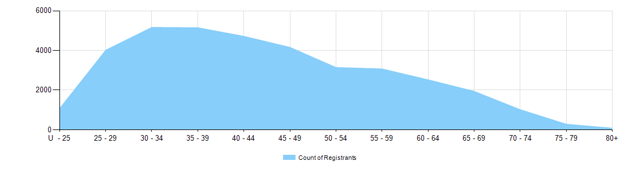
Gender
- Registration type
  - Psychology registrants by gender, by state and territory and by registration type
Gender | Registration type |  | ACT | NSW | NT | QLD | SA | TAS | VIC | WA | No PPP | Total
Female | General |  | 664 | 7,734 | 157 | 4,200 | 1,125 | 410 | 6,566 | 2,410 | 263 | 23,529
Female | Provisional |  | 98 | 1,309 | 23 | 779 | 162 | 78 | 1,188 | 538 | 8 | 4,183
Female | Non-practising |  | 25 | 447 | 1 | 219 | 68 | 22 | 279 | 118 | 158 | 1,337
Total female |  |  | 787 | 9,490 | 181 | 5,198 | 1,355 | 510 | 8,033 | 3,066 | 429 | 29,049
Male | General |  | 146 | 2,032 | 44 | 1,062 | 357 | 95 | 1,625 | 616 | 90 | 6,067
Male | Provisional |  | 16 | 314 | 5 | 191 | 43 | 16 | 253 | 92 | 2 | 932
Male | Non-practising |  | 12 | 118 | 1 | 52 | 17 | 7 | 55 | 19 | 44 | 325
Total male |  |  | 174 | 2,464 | 50 | 1,305 | 417 | 118 | 1,933 | 727 | 136 | 7,324
Intersex or Indeterminate |  | General |  | 2 |  |  |  |  |  |  |  | 2
 |  | Provisional |  |  |  |  |  |  |  | 1 |  | 1
Total Intersex or Indeterminate |  |  |  | 2 |  |  |  |  |  | 1 |  | 3
Total |  |  | 961 | 11,956 | 231 | 6,503 | 1,772 | 628 | 9,966 | 3,794 | 565 | 36,376

- Percentage
  - Registrants by gender percentages
Gender | ACT | NSW | NT | QLD | SA | TAS | VIC | WA | No PPP | Total
Female | 81.9% | 79.4% | 78.4% | 79.9% | 76.5% | 81.2% | 80.6% | 80.8% | 75.9% | 79.9%
Male | 18.1% | 20.6% | 21.6% | 20.1% | 23.5% | 18.8% | 19.4% | 19.2% | 24.1% | 20.1%
Intersex or Indeterminate |  | <0.1% |  |  |  |  |  | <0.1% |  | <0.1%

1 There were 29,598 psychologists with general registration after the close of business on 30 June 2018.
Provisional psychologists hold provisional registration which is the registration type under section 62 of the National Law that enables the individual to undertake a period of supervised practice in order to become eligible for general registration. There are different pathways that can be undertaken by registered provisional psychologists including the 4+2 internship program, the 5+1 internship program, and higher degree programs. Refer to the Provisional registration section of the Board’s website www.psychologyboard.gov.au for more information on the pathways.
3 Since 1 July 2013 all supervisors of psychology higher degree students undertaking placements must be approved by the Board.
4 Refer to the Board’s Policy on working in addition to placements.

