

Psychology Board of Australia

Registrant data

Reporting period: 1 October 2018 – 31 December 2018

Table of contents
Introduction 3
Principal Place of Practice 4
1. Registration type 4
Endorsements 5
2. Endorsement by PPP 5
3. Number of endorsements 5
Supervisors 7
4. Board-approved supervisors 7
5. Registrar program supervisors 8
Age Group 9
7. Registration type by age group 9
Gender 10
8. Registration type 10
9. Percentage 10

Introduction
The role of the Psychology Board of Australia (the Board) includes:
- registering psychologists and provisional psychologists
- developing standards, codes and guidelines for the psychology profession
- handling notifications, complaints, investigations and disciplinary hearings
- overseeing the assessment of overseas trained psychologists who wish to practise in Australia, and
- approving accreditation standards and accredited courses of study.
The Board’s functions are supported by the Australian Health Practitioner Regulation Agency (AHPRA). For information about legislation governing our operations see About AHPRA at www.ahpra.gov.au/About-AHPRA/What-We-Do/Legislation.aspx.
The Board has analysed its registration data and produced a number of statistical breakdowns about registrants to share with the profession and community. The Board shares these breakdowns regularly.
For more information on psychology registration, please see the Board’s website www.psychologyboard.gov.au/Registration.aspx

Principal Place of Practice
Principal Place of Practice (PPP) is the address declared by the psychologist to be the address at which he or she is predominantly practising the profession. If the psychologist is not practising the profession or is not practising predominantly at one address the Principal Place of Practice may be the psychologist’s principal place of residence.
The ‘No PPP’ column in the tables on the following pages represents psychologists who do not have an Australian Principal Place of Practice recorded on the register usually because they are currently residing overseas or who have not provided a valid PPP.

- Registration Type
  - Registration type by principal place of practice
Registration Type | ACT | NSW | NT | QLD | SA | TAS | VIC | WA | No PPP | Total
General | 817 | 9,842 | 197 | 5,346 | 1,494 | 516 | 8,310 | 3,049 | 412 | 29,983
Provisional | 112 | 1,591 | 27 | 963 | 211 | 88 | 1,394 | 613 | 15 | 5,014
Non-practising | 40 | 565 | 2 | 286 | 85 | 31 | 342 | 147 | 207 | 1,705
Total | 969 | 11,998 | 226 | 6,595 | 1,790 | 635 | 10,046 | 3,809 | 634 | 36,702

  - Registration by principal place of practice percentages

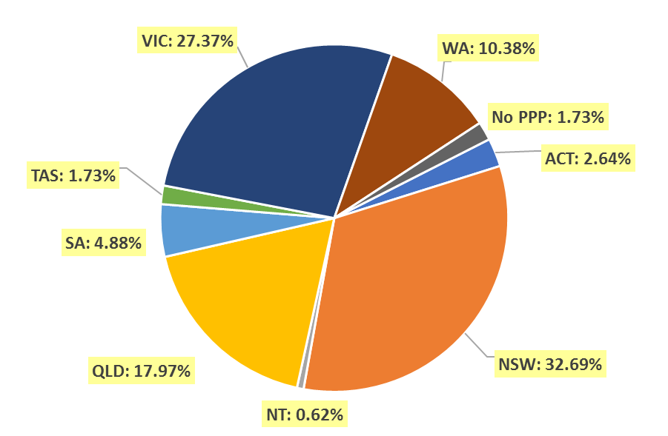
Endorsements
- Area of practice endorsements by PPP
  - Area of practice endorsements by state or territory
Area of practice | ACT | NSW | NT | QLD | SA | TAS | VIC | WA | No PPP | Total
Clinical neuropsychology | 10 | 167 | 2 | 107 | 26 | 6 | 312 | 35 | 12 | 677
Clinical psychology | 266 | 2,643 | 35 | 1,420 | 655 | 204 | 2,227 | 1,159 | 116 | 8,725
Community psychology | 1 | 6 |  | 3 | 1 |  | 34 | 10 |  | 55
Counselling psychology | 10 | 199 |  | 77 | 11 | 8 | 498 | 153 | 9 | 965
Educational and developmental psychology | 10 | 158 | 2 | 125 | 34 | 19 | 255 | 68 | 8 | 679
Forensic psychology | 13 | 231 | 5 | 68 | 37 | 9 | 176 | 48 | 5 | 592
Health psychology | 6 | 65 | 1 | 60 | 30 | 10 | 146 | 5 | 3 | 326
Organisational psychology | 18 | 176 | 2 | 79 | 50 | 2 | 156 | 42 | 7 | 532
Sport and exercise psychology | 6 | 21 | 1 | 27 | 7 | 3 | 22 | 6 |  | 93
Total | 340 | 3,666 | 48 | 1,966 | 851 | 261 | 3,826 | 1,526 | 160 | 12,644
The figures in the table above show the total number of psychology area of practice endorsements recorded on the National Register. Psychologists who hold more than one endorsement are counted for each endorsement they hold. The number of individual psychologists who hold at least one area of practice endorsement after the close of business on 31 December 2018 was 11,605.

- Number of Endorsements
  - Number of endorsements held
Endorsement | 1 | 2 | 3 | 4 | 5 | 6 | Total
Number of endorsed psychologists | 10,645 | 894 | 56 | 8 | 1 | 1 | 11,605
% of endorsed psychologists | 91.7% | 7.7% | 0.5% | 0.1% | <0.1% | <0.1% | 100.0%
Number of psychologists with general registration (endorsed and non-endorsed) |  |  |  |  |  |  | 29,984
% of all general psychologists with one or more endorsement | 35.5% | 3.0% | 0.2% | <0.1% | <0.1% | <0.1% | 38.7%

  - Psychologists with one endorsement per registrant and total number of endorsements – by area of practice
Area of practice | Psychologists with one endorsement | % of psychologists with one endorsement | Total endorsements | % of total endorsements
Clinical neuropsychology | 520 | 4.9% | 677 | 5.4%
Clinical psychology | 7,905 | 74.3% | 8,725 | 69.0%
Community psychology | 29 | 0.3% | 55 | 0.4%
Counselling psychology | 654 | 6.1% | 965 | 7.6%
Educational and developmental psychology | 499 | 4.7% | 679 | 5.4%
Forensic psychology | 335 | 3.1% | 592 | 4.7%
Health psychology | 167 | 1.6% | 326 | 2.6%
Organisational psychology | 462 | 4.3% | 532 | 4.2%
Sport and exercise psychology | 74 | 0.7% | 93 | 0.7%
Total | 10,645 | 100.0% | 12,644 | 100.0%
The sum of individual proportions may not add up to 100% due to rounding.
Supervisors
- Board-approved supervisors
  - Approved supervisors by PPP
PPP | Number of approved supervisors | % of general registrants
ACT | 246 | 25.4%
NSW | 2,598 | 21.7%
NT | 56 | 24.8%
QLD | 1,446 | 21.9%
SA | 420 | 23.5%
TAS | 170 | 26.8%
VIC | 1,921 | 19.1%
WA | 912 | 23.9%
No PPP | 40 | 6.3%
Total | 7,809 | 21.3%

  - Change in the number of approved supervisors
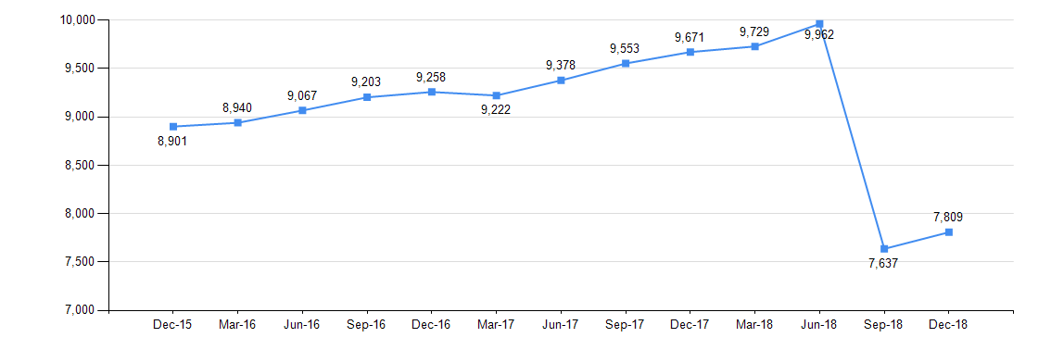
8,500 psychologists were approved, under transitional arrangements in 2013, to provide supervision until 30 June 2018. 2,900 did not renew their supervision approvals, accounting for the decline in total approved supervisors in September 2018.
- Registrar program supervisors
  - Registrar program principal supervisors
Area of practice | ACT | NSW | NT | QLD | SA | TAS | VIC | WA | No PPP | Total
Clinical neuropsychology | 6 | 84 | 2 | 55 | 14 | 4 | 186 | 21 | 4 | 376
Clinical psychology | 121 | 1,041 | 19 | 603 | 257 | 84 | 908 | 495 | 14 | 3,542
Community psychology | 1 | 2 | 1 | 1 | 1 | 1 | 19 | 2 | 1 | 29
Counselling psychology | 3 | 43 | 1 | 36 | 5 | 1 | 174 | 66 | 1 | 330
Educational and developmental psychology | 2 | 56 | 1 | 61 | 16 | 7 | 89 | 23 | 1 | 256
Forensic psychology | 9 | 118 | 4 | 34 | 20 | 5 | 80 | 26 | 3 | 299
Health psychology | 5 | 23 | 1 | 30 | 14 | 3 | 60 | 1 | 1 | 138
Organisational psychology | 6 | 59 | 1 | 40 | 16 | 2 | 60 | 13 | 1 | 198
Sport and exercise psychology | 1 | 3 | 1 | 9 | 2 | 1 | 4 | 1 | 1 | 23
Total | 154 | 1,429 | 31 | 869 | 345 | 108 | 1,580 | 648 | 27 | 5,191
Age group
- Registration type by age group
  - Registration type by age group
Age Group | General | Provisional | Non-practising | Total
U - 25 | 32 | 805 | 1 | 838
25 - 29 | 2,057 | 1,813 | 36 | 3,906
30 - 34 | 4,022 | 884 | 269 | 5,175
35 - 39 | 4,515 | 504 | 273 | 5,292
40 - 44 | 4,159 | 366 | 187 | 4,712
45 - 49 | 3,881 | 295 | 151 | 4,327
50 - 54 | 2,894 | 189 | 104 | 3,187
55 - 59 | 2,869 | 104 | 125 | 3,098
60 - 64 | 2,396 | 41 | 163 | 2,600
65 - 69 | 1,823 | 8 | 201 | 2,032
70 - 74 | 965 | 3 | 133 | 1,101
75 - 79 | 285 | 2 | 49 | 336
80+ | 85 |  | 13 | 98
Total | 29,983 | 5,014 | 1,705 | 36,702

  - Registrants by age group
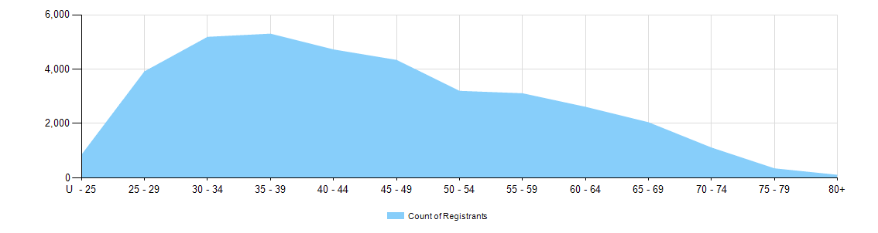
Gender
- Registration type
  - Psychology registrants by gender, by state and territory and by registration type
Gender | Registration type |  | ACT | NSW | NT | QLD | SA | TAS | VIC | WA | No PPP | Total
Female | General |  | 663 | 7,807 | 153 | 4,276 | 1,138 | 420 | 6,672 | 2,433 | 308 | 23,870
Female | Provisional |  | 96 | 1,287 | 23 | 761 | 167 | 74 | 1,141 | 519 | 14 | 4,082
Female | Non-practising |  | 26 | 444 | 1 | 233 | 66 | 23 | 283 | 124 | 164 | 1,364
Total female |  |  | 785 | 9,538 | 177 | 5,270 | 1,371 | 517 | 8,096 | 3,076 | 486 | 29,316
Male | General |  | 154 | 2,033 | 44 | 1,070 | 356 | 96 | 1,638 | 616 | 104 | 6,111
Male | Provisional |  | 16 | 304 | 4 | 202 | 44 | 14 | 253 | 93 | 1 | 931
Male | Non-practising |  | 14 | 121 | 1 | 53 | 19 | 8 | 59 | 23 | 43 | 341
Total male |  |  | 184 | 2,458 | 49 | 1,325 | 419 | 118 | 1,950 | 732 | 148 | 7,383
Intersex or Indeterminate |  | General |  | 2 |  |  |  |  |  |  |  | 2
 |  | Provisional |  |  |  |  |  |  |  | 1 |  | 1
Total Intersex or Indeterminate |  |  | 0 | 2 | 0 | 0 | 0 | 0 | 0 | 1 | 0 | 3
Total |  |  | 969 | 11,998 | 226 | 6,595 | 1,790 | 635 | 10,046 | 3,809 | 634 | 36,702

- Percentage
  - Registrants by gender percentages
Gender | ACT | NSW | NT | QLD | SA | TAS | VIC | WA | No PPP | Total
Female | 81.0% | 79.5% | 78.3% | 79.9% | 76.6% | 81.4% | 80.6% | 80.8% | 76.7% | 79.9%
Male | 19.0% | 20.5% | 21.7% | 20.1% | 23.4% | 18.6% | 19.4% | 19.2% | 23.3% | 20.1%
Intersex or Indeterminate |  | <0.1% |  |  |  |  |  | <0.1% |  | <0.1%

